Payment System

We design a payment system. E-commerce & other services online have exploded in popularity across the world. What makes every transaction possible is a payment-system running behind the scenes. A reliable, scalable, and flexible payment system is essential.
What is a payment system? According to Wikipedia, “A payment system is any system used to settle financial transactions through the transfer of monetary value. This includes the institutions, instruments, people, rules, procedures, standards, and technologies that make its exchange possible”.
- A merchant is any individual or business that sells goods or services and accepts payments from customers using card payments, UPI, net banking, wallets, or other payment methods.
- A payment system processes online payments. It enables merchants to accept credit cards and other forms of electronic payments(Netbanking, UPI, Wallets, BNPL-Buy Now Pay Later, etc) securely over the Internet.
- A payment service provider (PSP) is a company that offers end-to-end payment processing services to merchants, including payment gateways, merchant accounts, and integration with multiple payment methods (cards, wallets, UPI, etc.) Popular payment service providers include PayPal, Stripe, Square etc. Handles the entire payment flow (gateway + processing + settlement + merchant onboarding).
- A payment gateway is a technology that facilitates the transfer of payment information between a merchant’s website/app and the payment processor. It is responsible for encrypting and securely transmitting transaction details.
The payment system is easy to understand on the surface but is also intimidating for many developers to work on. A small slip could potentially cause significant revenue loss and destroy credibility among users.

Key Pointers:
- Assume you are building a payment backend for a client application where customers buy products/services online like Amazon. When a customer places an order, the payment system handles everything related to money movement.
- The payment system should support all of these options in real life. Like Cards or Alternate Payment Methods (APM) - (Netbanking, UPI, Wallets, BNPL-Buy Now Pay Later etc).
- PaymentMethod: Card, APM. When we directly capture & process card details on our website, then we will use paymentMethod: Card. Else we use APM (Including capture card indirectly at PSP)
- For Direct Card Processing, we generally tend to use third-party payment processors (Cardinity, Kalixa, etc). Due to extremely high security and compliance requirements, storing card numbers directly in our system needs Payment Card Industry Data Security Standard (PCI DSS).
- For Alternate Payment Methods (APM) processing, we integrate with the corresponding 3rd party provider. We need to understand end-to-end integration with each of the 3rd party. And build a secure, stable integration and enable the end customer to make payment via that 3rd party provider.
- Load/Scale of around 1 million transactions per day. 10-15 transactions per second.
- PaymentMethod: APM, Card
- Payment Service Provider (PSP): Paypal, Stripe, Trustly, Square etc
- PaymentType: SALE (One time payment), RECC (Subscriptions)
- Hosted Page - the Payment page provided by the PSP. Ecom application redirects the customer to the hosted page, where they complete their transactions. And would return back to the ecom website.
- Reliability and fault tolerance. Failed payments need to be carefully handled.

Functional requirements
- To build a Pay-in / Deposit / Sale / Checkout flow: Money moves from the end customer account to the merchant account
Overview:
- Pay-in flow: payment system receives money from customers on behalf of sellers.
- Pay-out flow: payment system sends money to sellers around the world.
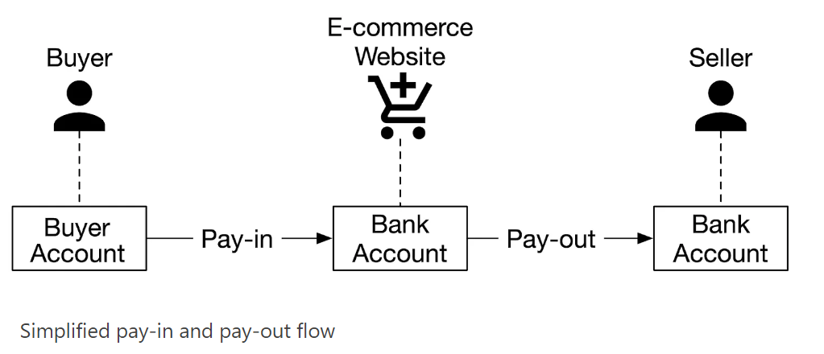

PayPal Pay-In / Checkout Flow (Merchant View)
- Customer places an order on your website and selects PayPal to pay.
- Customer logs into their PayPal account and completes the payment using:
  - PayPal Balance, Linked Bank Account, Debit/Credit Card
- PayPal processes the payment and deducts its fee before crediting you
- Remaining money is credited to your PayPal Merchant Account.
- You choose to withdraw the balance to your linked bank account.

Pay-in / Deposit / Sale / Checkout flow (Payment System Overview)
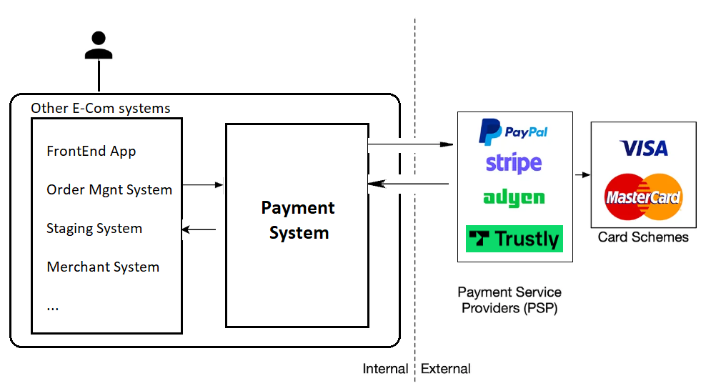
PSP integration
We are integrating with PayPal PSP. PayPal is a globally trusted payment service provider known for its reliability, security, and ease of use, offering a comprehensive platform for businesses and individuals to send and receive payments online. With its wide adoption across various industries and regions, PayPal enables seamless transactions, supports multiple currencies, and provides powerful fraud protection. By streamlining the payment process and enhancing user experience, PayPal remains a top choice for businesses of all sizes, ensuring secure, quick, and hassle-free online payments while expanding your global reach.
PayPal Payment Integration:
- https://developer.paypal.com/studio/checkout/standard/getstarted
- https://developer.paypal.com/docs/api/orders/v2/#orders_create
- https://developer.paypal.com/docs/api/orders/v2/#orders_capture
- https://developer.paypal.com/api/rest/
- https://www.paypal.com/signin/client?flow=provisionUser&country.x=US&locale.x=en_US
- https://developer.paypal.com/dashboard/
- https://sandbox.paypal.com

Standard Checkout flow:
Reference:
https://developer.paypal.com/studio/checkout/standard/getstarted

